**Pom.xml**

<?xml version="1.0" encoding="UTF-8"?>

<project xmlns="http://maven.apache.org/POM/4.0.0" xmlns:xsi="http://www.w3.org/2001/XMLSchema-instance"

xsi:schemaLocation="http://maven.apache.org/POM/4.0.0 https://maven.apache.org/xsd/maven-4.0.0.xsd">

<modelVersion>4.0.0</modelVersion>

<parent>

<groupId>org.springframework.boot</groupId>

<artifactId>spring-boot-starter-parent</artifactId>

<version>2.7.10</version>

<relativePath/> <!-- lookup parent from repository -->

</parent>

<groupId>com.cdac</groupId>

<artifactId>Spring-Boot-Hibernate-CRUD-App</artifactId>

<version>0.0.1-SNAPSHOT</version>

<name>Spring-Boot-Hibernate-CRUD-App</name>

<description>Welcome project for Spring Boot</description>

<properties>

<java.version>11</java.version>

</properties>

<dependencies>

<dependency>

<groupId>org.springframework.boot</groupId>

<artifactId>spring-boot-starter-data-jpa</artifactId>

</dependency>

<dependency>

<groupId>org.springframework.boot</groupId>

<artifactId>spring-boot-starter-web</artifactId>

</dependency>

<dependency>

<groupId>com.mysql</groupId>

<artifactId>mysql-connector-j</artifactId>

<scope>runtime</scope>

</dependency>

<dependency>

<groupId>org.springframework.boot</groupId>

<artifactId>spring-boot-starter-test</artifactId>

<scope>test</scope>

</dependency>

</dependencies>

<build>

<plugins>

<plugin>

<groupId>org.springframework.boot</groupId>

<artifactId>spring-boot-maven-plugin</artifactId>

</plugin>

</plugins>

</build>

</project>

**Application.properties**

# JDBC PROPERTIES

spring.datasource.url=jdbc:mysql://localhost:3306/pune?useSSL=false&allowPublicKeyRetrieval=true

spring.datasource.username=root

spring.datasource.password=cdac

# HIBERNATE PROPERTIES

spring.jpa.properties.hibernate.dialect=org.hibernate.dialect.MySQL5Dialect

spring.jpa.hibernate.ddl-auto=update

## Show sql query.

spring.jpa.show-sql=true

**Product.java**

package com.cdac.model;

import javax.persistence.Entity;

import javax.persistence.GeneratedValue;

import javax.persistence.GenerationType;

import javax.persistence.Id;

import javax.persistence.Table;

*@Entity*

*@Table*(name="table_product")

public class Product {

*@Id*

*@GeneratedValue*(strategy = *GenerationType*.***IDENTITY***)

private int id;

private String name;

private float price;

public int getId() {

return id;

}

public void setId(int id) {

this.id = id;

}

public String getName() {

return name;

}

public void setName(String name) {

this.name = name;

}

public float getPrice() {

return price;

}

public void setPrice(float price) {

this.price = price;

}

}

**ProductDao.java**

package com.cdac.dao;

import org.springframework.data.jpa.repository.JpaRepository;

import org.springframework.stereotype.Repository;

import com.cdac.model.Product;

*@Repository*

public interface ProductDao extends CrudRepository<Product, Integer> {

}

**ProductService.java**

package com.cdac.service;

import java.util.List;

import com.cdac.model.Product;

public interface ProductService {

public void add(Product product);

public void modify(Product product);

public void removeById(int id);

public Product getById(int id);

public List<Product> getAll();

public List<Product> getAllByName(String name);

public List<Product> getBySalary(float salary);

}

**ProductServiceImpl.java**

package com.cdac.service;

import java.util.ArrayList;

import java.util.List;

import java.util.Optional;

import org.springframework.beans.factory.annotation.Autowired;

import org.springframework.stereotype.Service;

import com.cdac.dao.ProductDao;

import com.cdac.model.Product;

*@Service*

public class ProductServiceImpl implements ProductService {

*@Autowired*

private ProductDao productDao;

*@Override*

public void add(Product product) {

productDao.save(product);

}

*@Override*

public void modify(Product product) {

productDao.save(product);

}

*@Override*

public void removeById(int id) {

productDao.deleteById(id);

}

*@Override*

public Product getById(int id) {

Optional<Product> opt = productDao.findById(id);

if (opt.isPresent()) {

return opt.get();

}

return null;

}

*@Override*

public List<Product> getAll() {

Iterable<Product> itr = productDao.findAll();

List<Product> lst = new ArrayList<Product>();

itr.forEach(ele -> lst.add(ele));

return lst;

}

*@Override*

public List<Product> getAllByName(String name) {

return productDao.findByName(name);

}

*@Override*

public List<Product> getBySalary(float price) {

return productDao.selectBySalary(price);

}

}

**ProductController.java**

package com.cdac.controller;

import java.util.List;

import org.springframework.beans.factory.annotation.Autowired;

import org.springframework.web.bind.annotation.DeleteMapping;

import org.springframework.web.bind.annotation.GetMapping;

import org.springframework.web.bind.annotation.PathVariable;

import org.springframework.web.bind.annotation.PostMapping;

import org.springframework.web.bind.annotation.PutMapping;

import org.springframework.web.bind.annotation.RequestBody;

import org.springframework.web.bind.annotation.RequestParam;

import org.springframework.web.bind.annotation.RestController;

import com.cdac.model.Product;

import com.cdac.service.ProductService;

*@RestController*

public class ProductController {

*@Autowired*

private ProductService productService;

*@PostMapping*(value = {"/product"})

public String productAdd(*@RequestBody* Product product) {

productService.add(product);

return "Product added successfully";

}

*@PutMapping*(value = {"/product"})

public String productUpdate(*@RequestBody* Product product) {

productService.modify(product);

return "Product updated successfully";

}

*@DeleteMapping*(value = {"/product"})

public String productDelete(*@RequestParam* int id) {

System.***out***.println("first delete");

productService.removeById(id);

return "Product deleted successfully";

}

*@GetMapping*(value = {"/product/{id}"})

public Product productGet(*@PathVariable* int id) {

return productService.getById(id);

}

*@GetMapping*(value = {"/product"})

public List<Product> productList(){

return productService.getAll();

}

}

**SpringBootHibernateCRUDAppApplication.java**

package com.cdac;

import org.springframework.boot.SpringApplication;

import org.springframework.boot.autoconfigure.SpringBootApplication;

*@SpringBootApplication*

public class SpringBootHibernateCrudAppApplication {

public static void main(String[] args) {

SpringApplication.*run*(SpringBootHibernateCrudAppApplication.class, args);

}

}

**Project Structure**

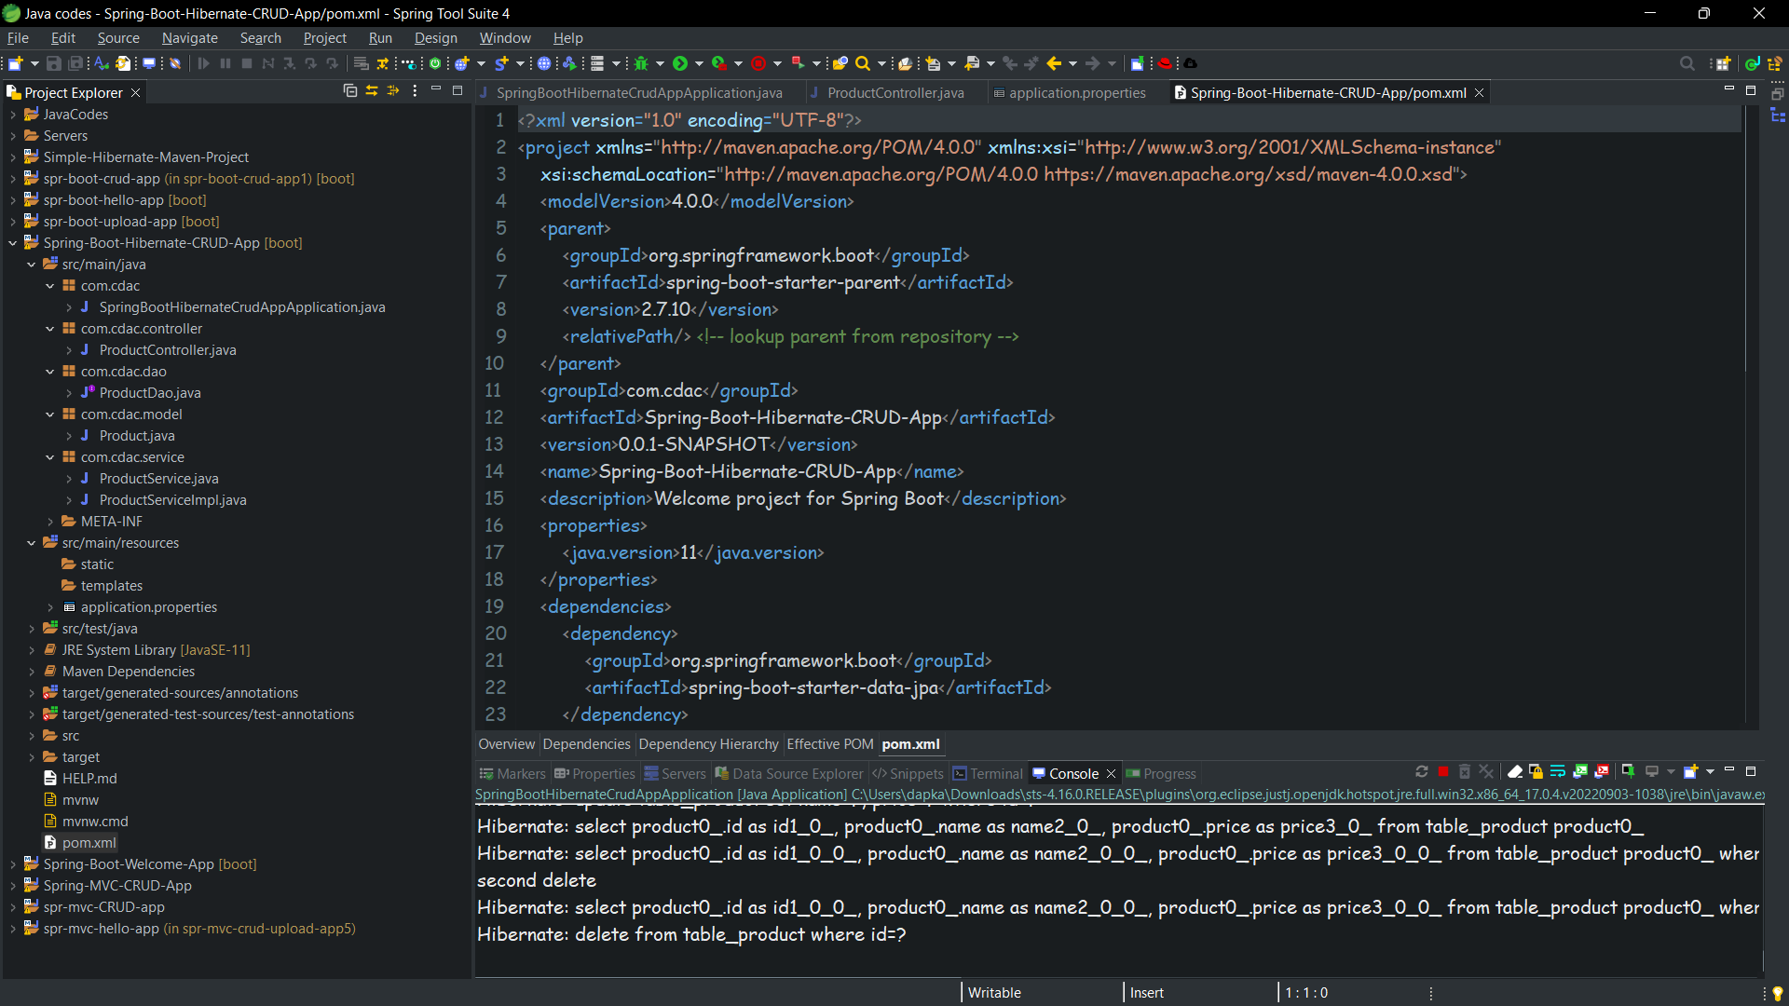

**Database Screenshots**

**Insert :**

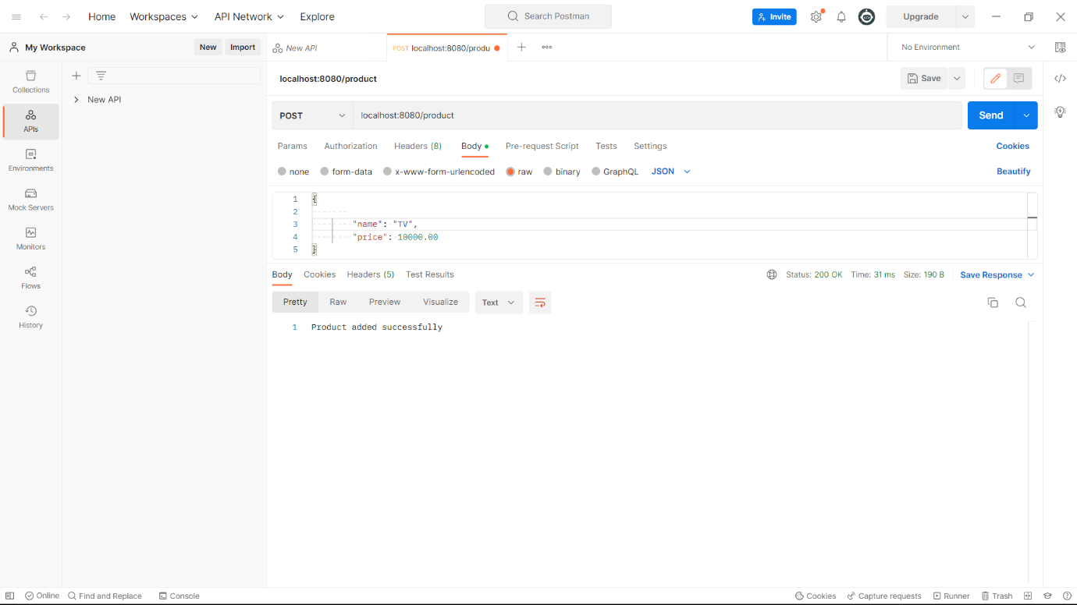

**Update :**

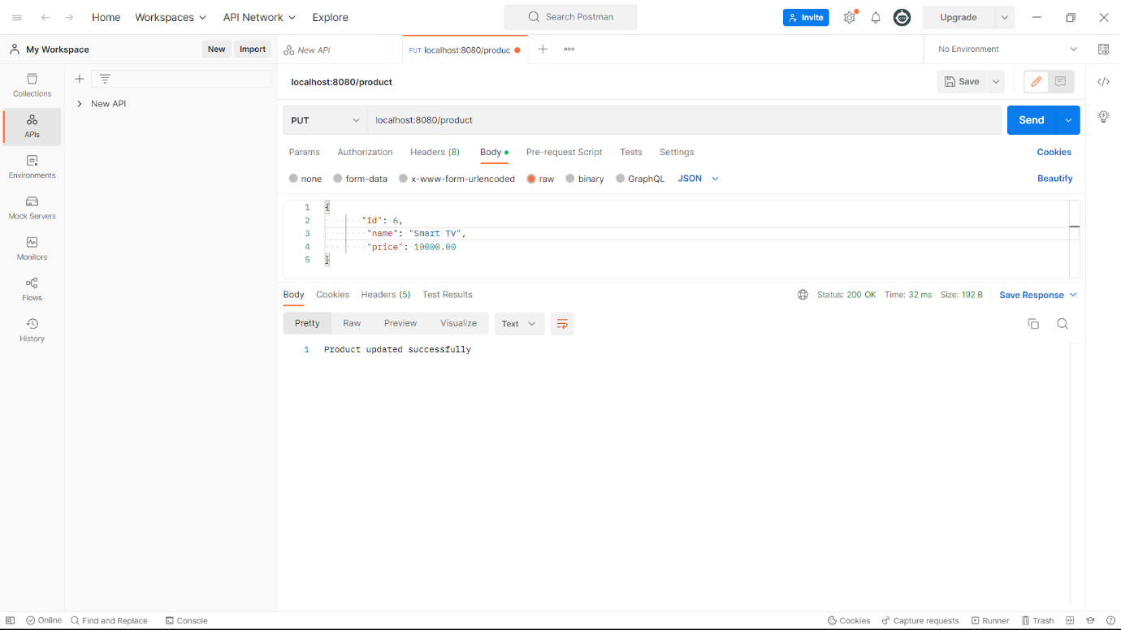

**Delete :**

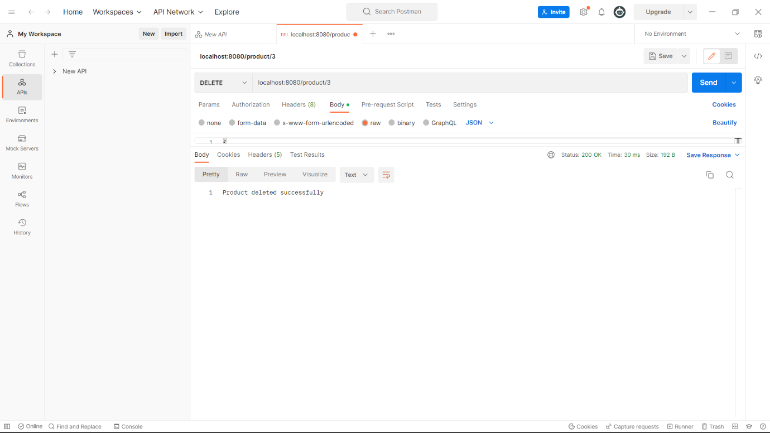

**Get by id :**

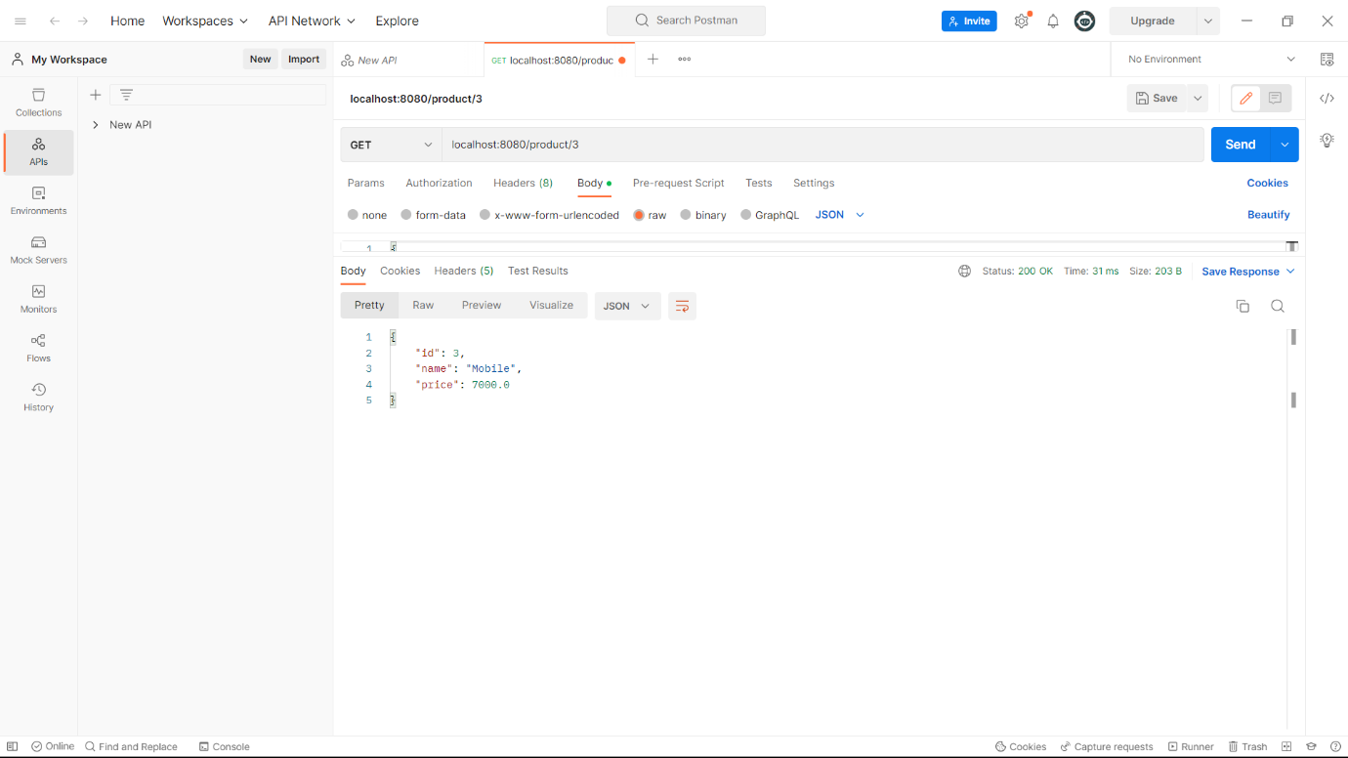

**Get all :**